**Software Project 01**

**Project Report**

**Project name:** Medicare

**Project description:** Medicare, our project idea is to create a platform that will provide our consumers with medical support at the proper time and proper place whenever they want. We will use **HTML**, **CSS**, and **JAVA Script** to develop the frontend part of our project. In the future, we will use **JAVA**, **Python**, **PHP**, **Ruby,** and other necessary programming languages to develop the backend part of our project. A responsive Database will be on the field also. The UI and UX of our project will be so informative and interactive that the consumers will feel so friendly to use our platform whenever they feel a problem.

**Frontend Part:**

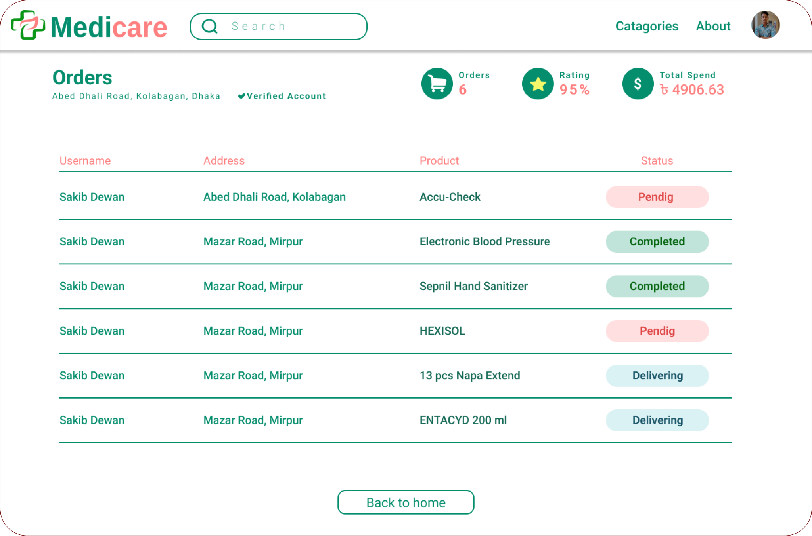

This is the order list page. This page will let our consumers monitor the order status. Number of orders, rating, and total cost amount will also be shown.

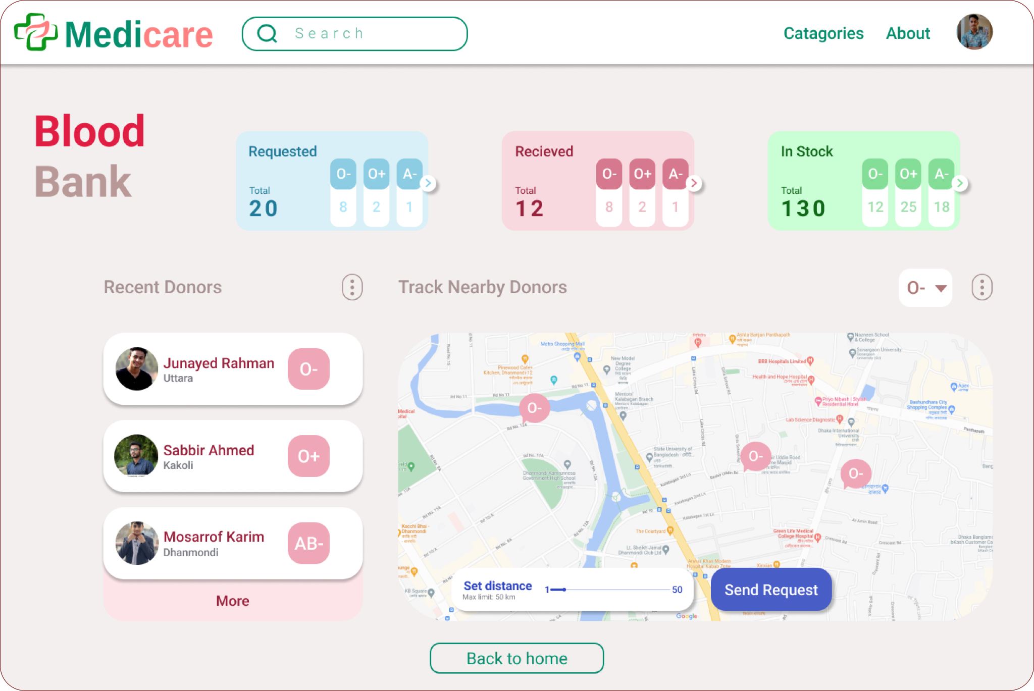

This page will allow our consumers to have facilities related to bool donation. The “More” button will show the recent donors list. The “Send Request” will post a donation request to the available donors around our consumers.

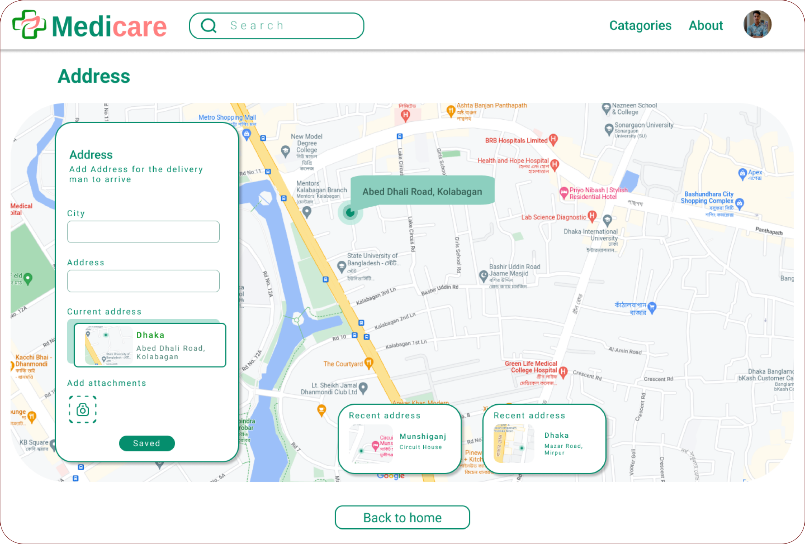

The address page will represent the address of our consumers. By using the fields on the left, consumers can add multiple addresses to their accounts.

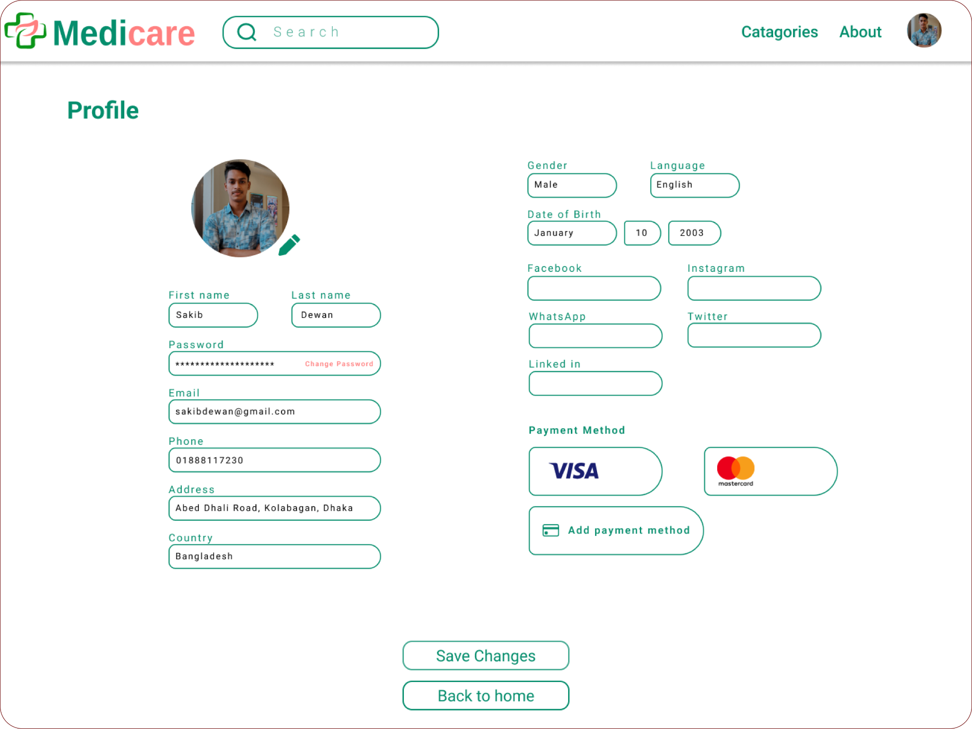

Here is the profile section of our project. Each and every field will allow our consumers to make changes to the particular section. The “Add Payment Method” button will show an option field to add more payment methods

**Backend Part:**

**API’s**

**GET | /order+medicine**

* This request will return the medicine list to the consumer.

**POST | /order+medicine/order**

* This request will post an order for the consumer.

**GET | /order/orderid**

* This request will return the order ID for the recently ordered product.

**DELETE | /order/orderid**

* This request will delete the order ID of the recently ordered product.

**PUT | /profile**

* This request will update all the changes that have been made to the profile.

**PUT | /profile/phone**

* This request will update the mobile number of the customer to the profile.

**DELETE | /profile/phone**

* This request will delete the mobile number updated by the consumer.

**GET | /recent+donors/more**

* This request will return the list of the donors who have donated blood recently.

**Database:**

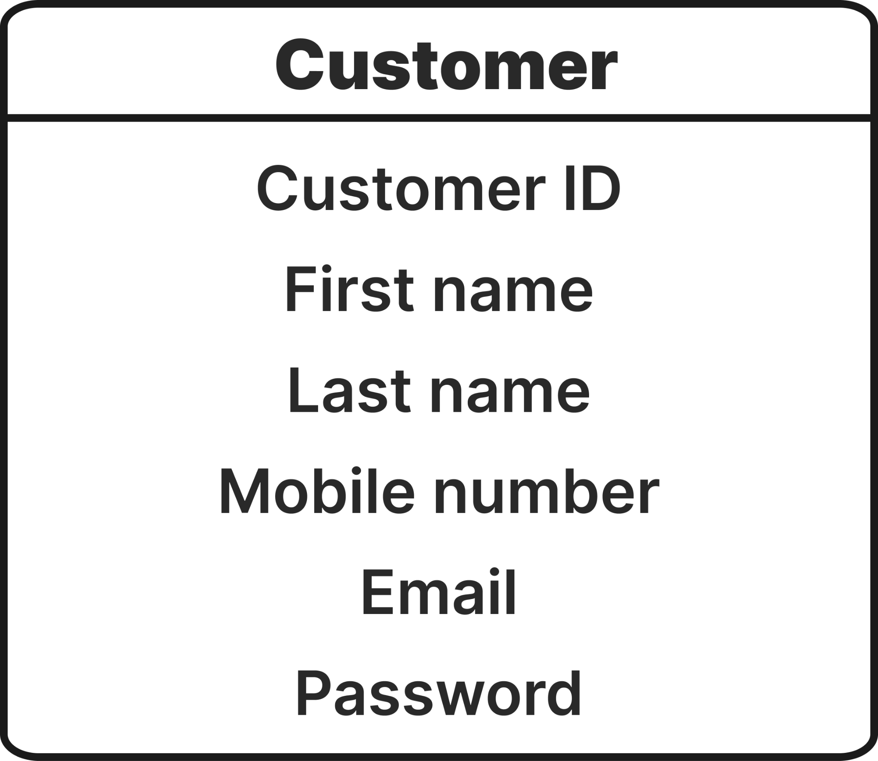

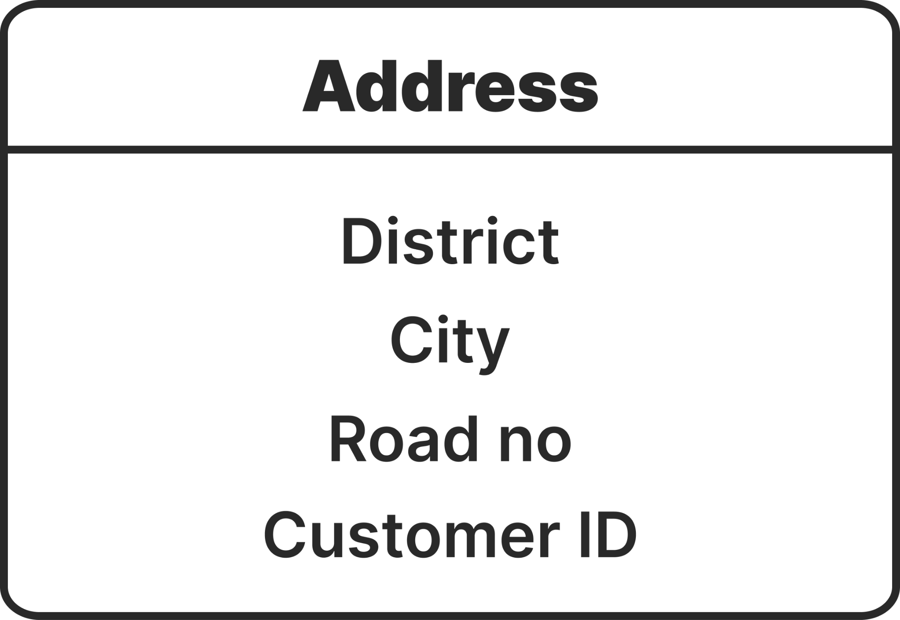

This is the datasheet that contains the customer details that were added to the profile. This table is connected to multiple tables in various relations. Such as, the **Customer table** is connected to the **Address table** with **one to many** relations because one customer simply can have multiple addresses. The **Address table** contains the address information of the customers.

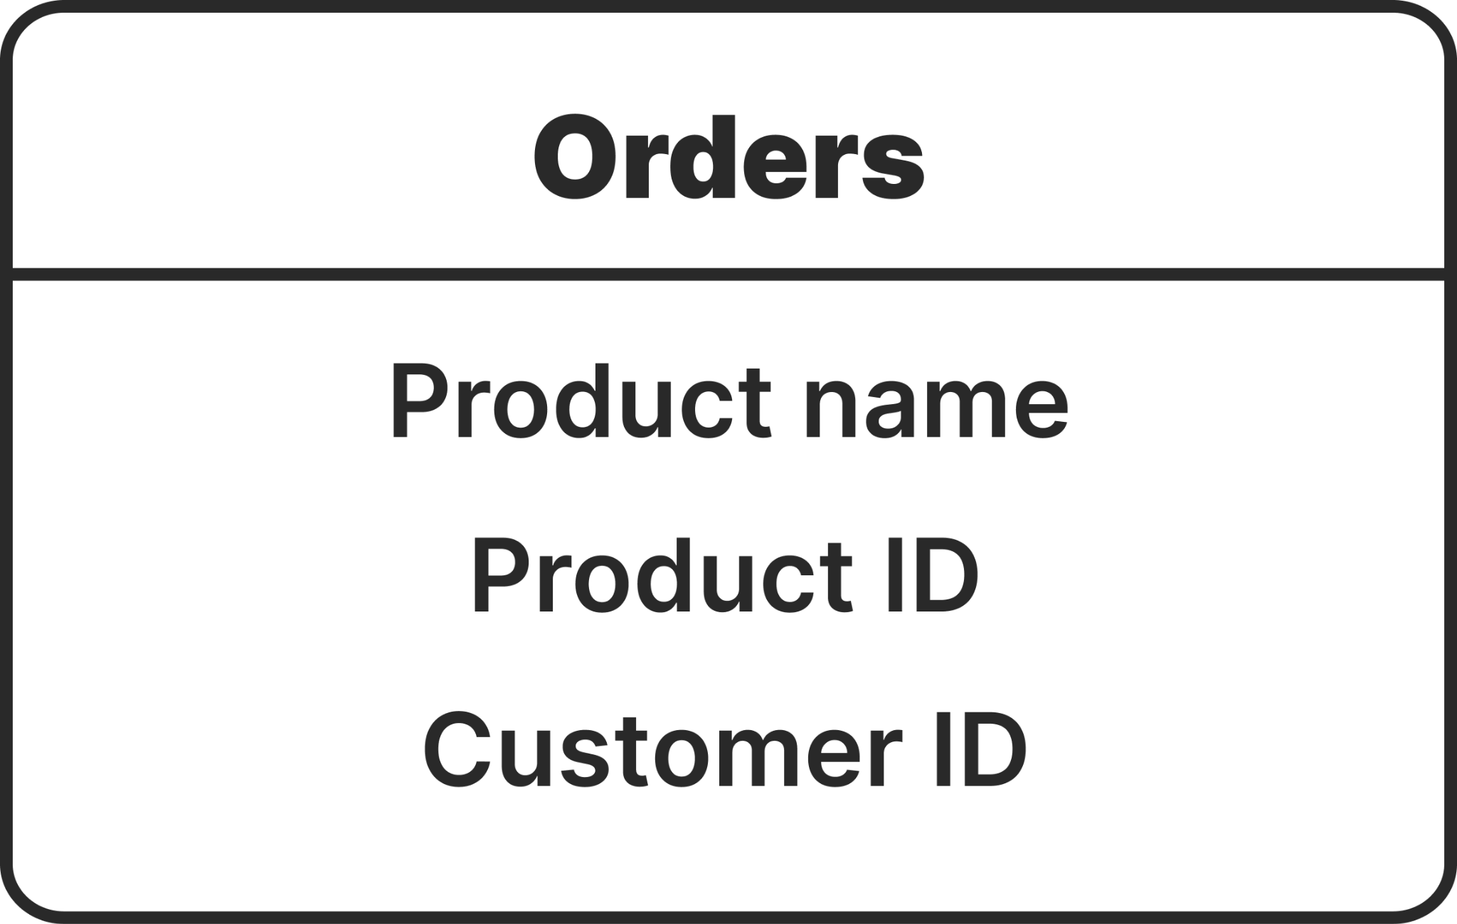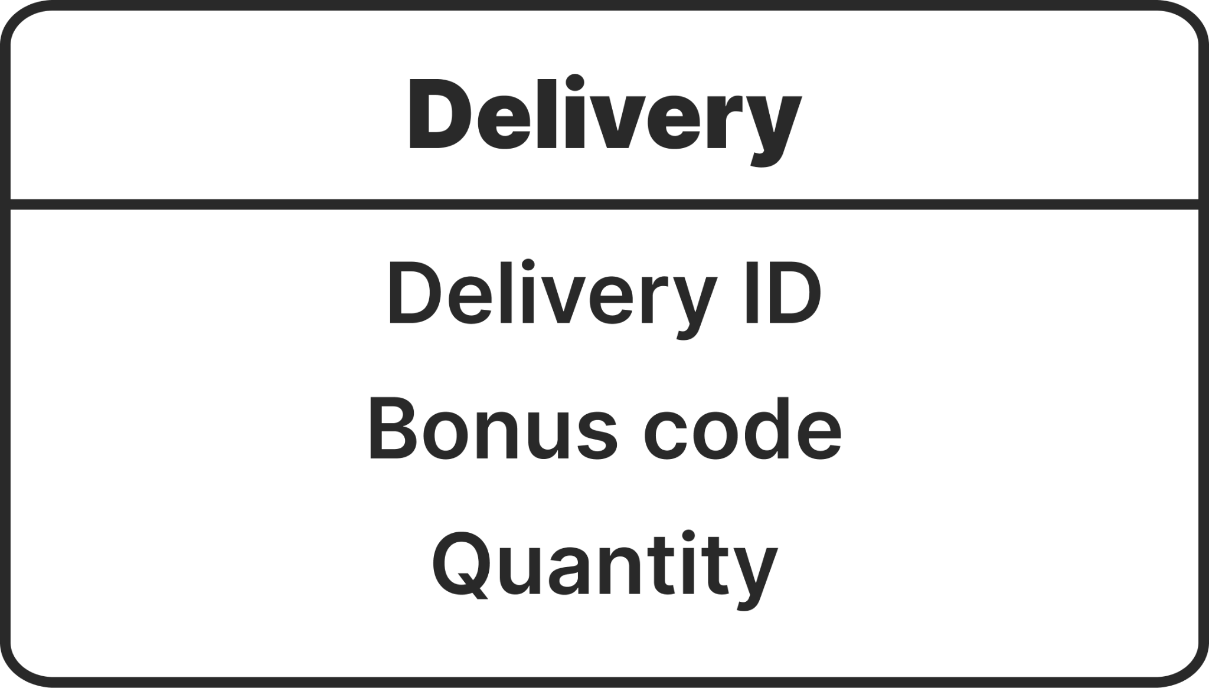

The **Order table** is connected to the **Customer table** with **many to one** relations as one customer can have multiple orders. The **Order table** contains the information of a product like product names, ID, etc.

Again, the **Order table** is connected to the **Delivery table** with **many to one** relation where multiple orders can have only one delivery ID to deliver.

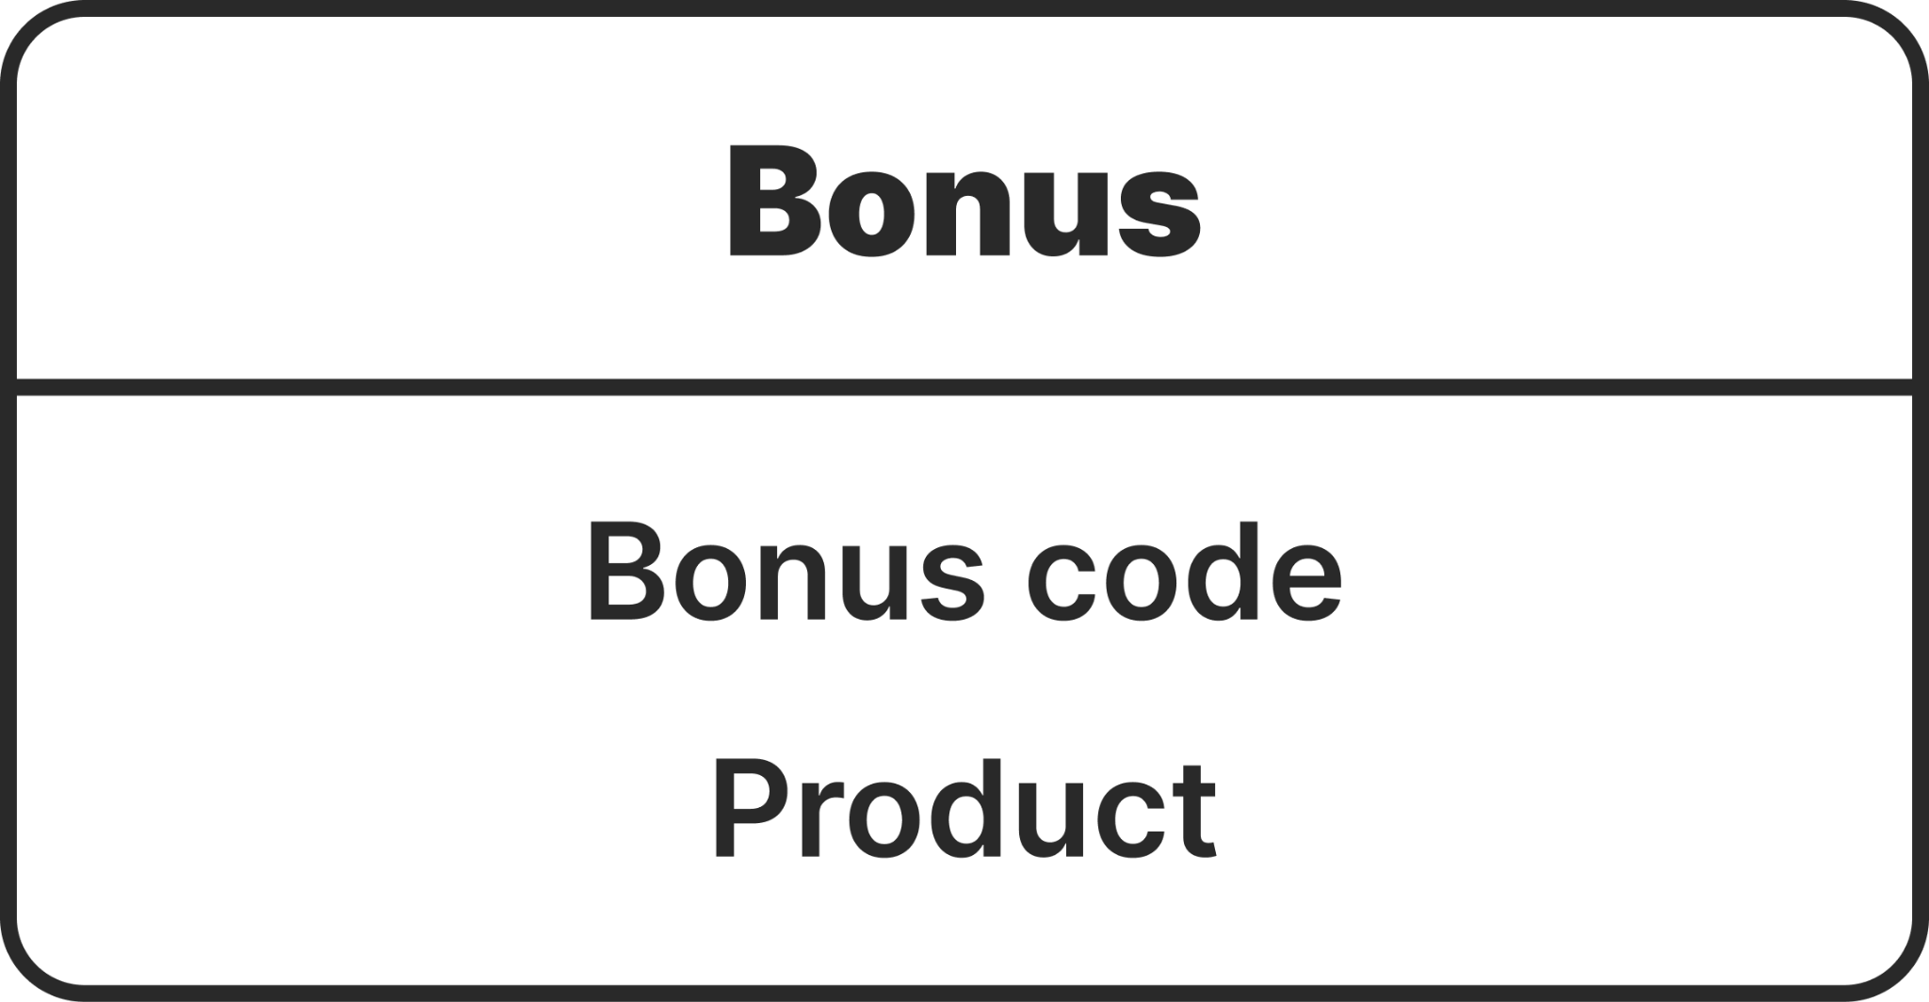

On the other hand, the **Bonus table** is connected to the **Delivery table** with **many to one** relations. So, the **Order table** and the **Bonus table** are connected with **many to many** relations.



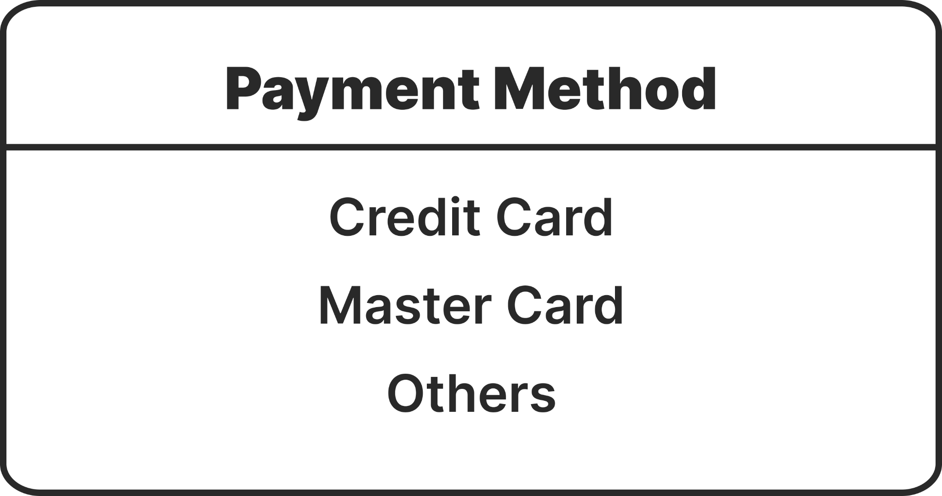

Again, the **Customer table** is connected to the **Payment method** table with **one to many** connections as a customer can have multiple payment methods.